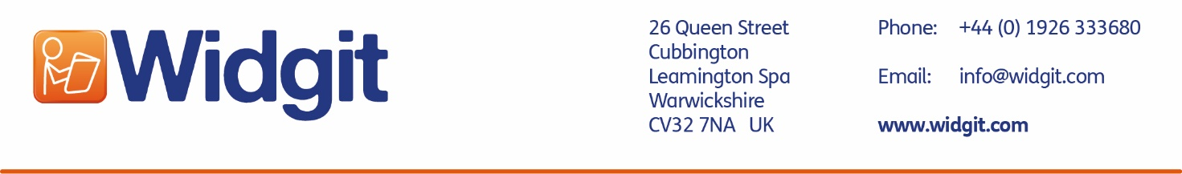

Widgit Symbol Licencing Questionnaire for Content

Please supply as much detail as possible in order to speed up your application.
Return the completed form to copyright@widgit.com

Organisation Details
Name:
Address:
Phone:
Website:

Business Contact Details
Name:
Phone:
Email:

About the Organisation
No. of employees:
Organisation type: | ☐Private Limited Company  ☐ Public limited company  ☐ Charity  ☐ School/College/University  ☐ NHS/Health/Care  ☐ Social enterprise  ☐ Start up  ☐ Individual  ☐ Other ____________________
If start up: | ☐ Pre-revenue  ☐ Early stage
Resource Description
Tell us what your resource is for and what it contains.
Please include either the full materials or samples with this questionnaire.

Resource Details
Name of Resource
Formats
e.g Printed booklet, leaflet, PDF, website
No. of copies
Or size of intended audience
Purpose
Intended use of the resource
Development Status
Released, in development, planning etc.
Release Date
Estimated release date if not already available
Retail Price/Payment Model
How much does the resource cost? Is it a one-time payment, subscription etc.
Who will be selling the resources
You or a third party – please give full details
Proposed Languages
Languages the resource is in
Proposed Territories
Where will the resources be sold / distributed

Symbols and Vocabulary
Total no. of symbols used
Approx. if resources not yet developed
No. of unique symbols used
Approx. if resources not yet developed
No. of pages
Approx. if resources not yet developed
How are you creating the resource?
e.g. InPrint 2, InPrint 3, SymWriter, Widgit Online, Indesign, Word, Publisher etc.
Do you need any files supplied by Widgit? | ☐ No  ☐ Yes
If yes, what format?
E.g. Jpg
What specifications?
E.g. print quality 3cm
Colour or black & white symbols?
What content?
If you know which symbols you want, please list them here.

Please note, there may be an additional charge for designing new symbols.

